Title of the Event | Market Research | 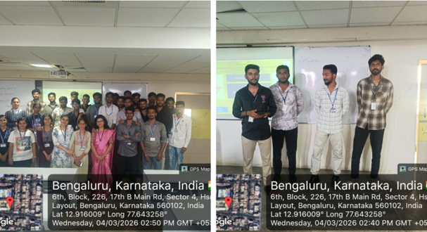
Day and Date | 4 March 2026
Venue (With all details ) | Room No- 309
In collaboration with ( if any)
Details of Resource Person With Designation |  | 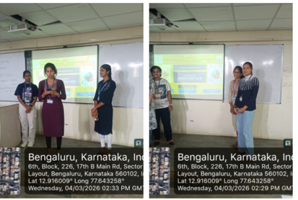
Organizing Department/Coordinators | Dr.Veto Dey ,Commerce and Management
Course and semester | MBA I Sem
No of Students & Faculty Participants | 35

Coordinator HoD Vice-Principal Principal

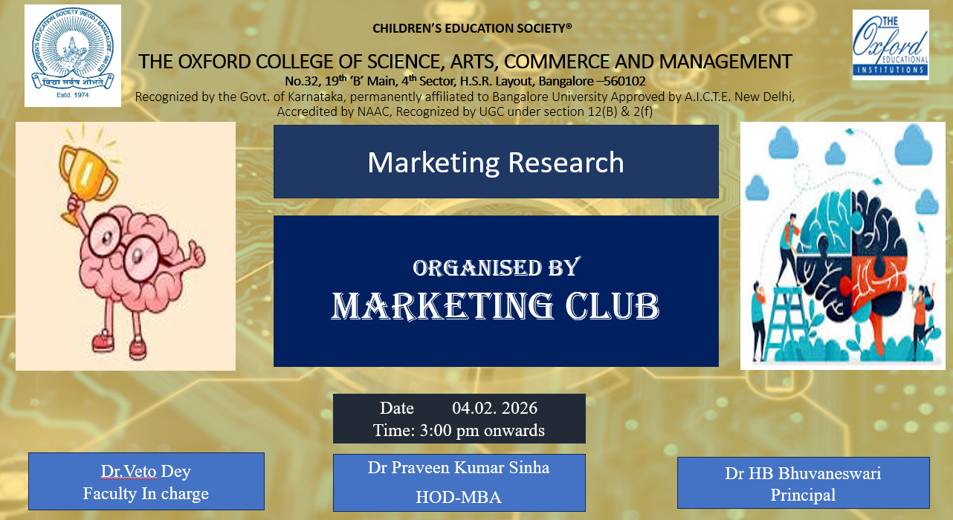
Introduction
The Department of MBA organized a “Market Research Activity” on 4 March 2026 during the Marketing Club hour for MBA Semester I students. The activity was conducted with the objective of providing students with practical exposure to market research techniques and consumer analysis.
Description of the Activity
The session focused on introducing students to the fundamentals of market research, including survey design, questionnaire preparation, and data collection methods. Students were guided on how to conduct surveys, collect responses, and analyze consumer preferences in real-time market situations. The activity encouraged active participation and helped students understand how market data is gathered and interpreted for business decision-making.
Outcome of the Activity
The activity helped students gain practical knowledge of market research and enhanced their understanding of consumer behavior and market analysis. It also improved their skills in survey design, data collection, and analytical thinking.
Conclusion
The Market Research Activity was an effective learning experience for MBA Semester I students. It successfully provided hands-on exposure to real-time market research practices and strengthened their understanding of marketing concepts.

